**DEVOPS CERTIFICATION MATERIAL**

**Class 1**

Topics of Devops

1. Introduction of devops
2. Git/Github.com
3. Jenkins
4. Ansible
5. Dockers
6. Kubernetes (K85)
7. Prometheus and Grafana
8. Ferreform

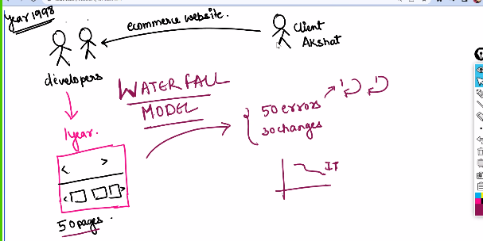 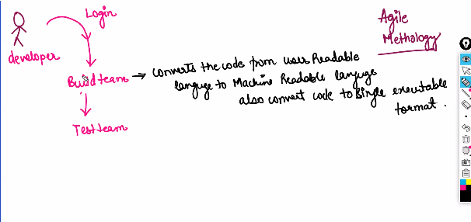

Build team🡪 Convert the codes from user readeable language to machine readeable language also convert code to single executable format (like war, jar)

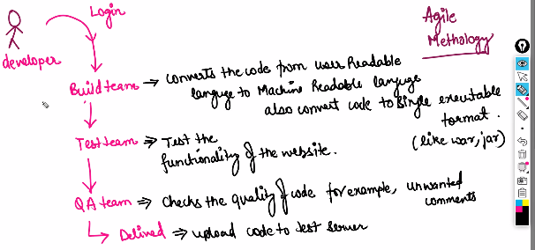

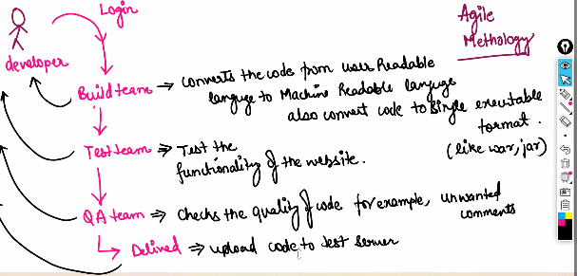

SDLC🡪 Software development life cycle

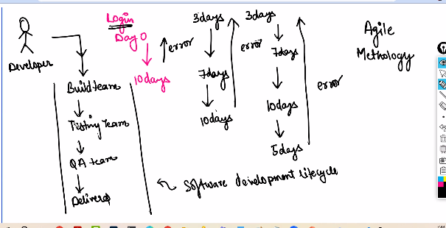

Instead of each teams the softwares going to performe the task automatically

With the help of Devops Automate the SDLC (Repository🡪Build🡪 Test 🡪 QA 🡪 Delivered)

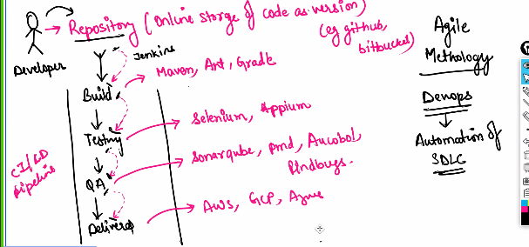

Automated Software like

Repository🡪 Git/Github

Build🡪 Maven, Ant, Gradle

Test 🡪 Selenium, Appium

QA 🡪 SonarQube, PMB, Ansible, Rind byes

Delivered 🡪 AWS, GCP, Azure

Monitoring 🡪 Prometheus and Grafana

**Version Control System (VCS)**

1. **Local version control system (LVCS)**

All the version of code saves in local.

Cons:

Local machine may get failure (Laptop issue)

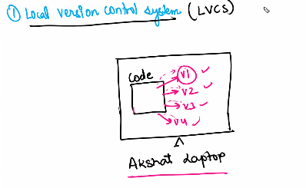

1. **Centralized version control system (CVCS)**

Every piece of code is saved in different versions.

Cons:

Network issue, Dependent on internet

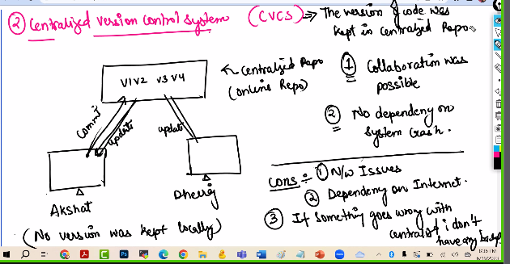

1. **Distributed version control System 🡪 CVCS + LVCS**

I will save all the version of code in centralized as well as local repository.

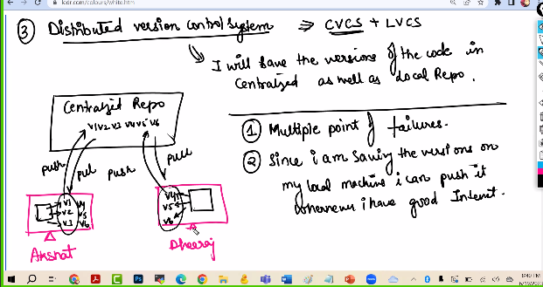

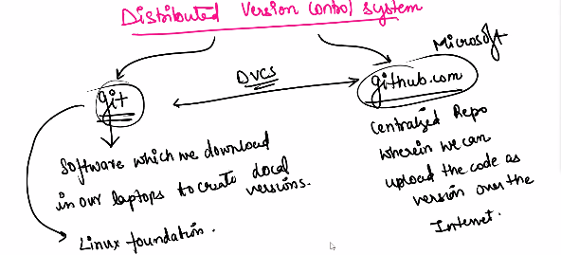

In Git bash we must initialize the code with the help of comment “git init”

Git add 🡪 Code will add from working directory to staging area.

Git status

Git commit-m”msg”🡪Create the version

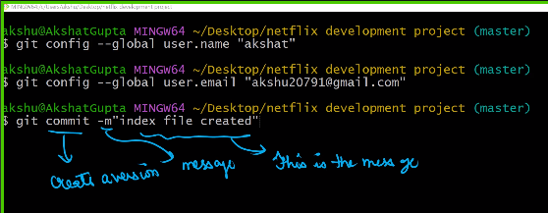

Git rm🡪 can remove the file

Git diff🡪 can check the content which is modified.

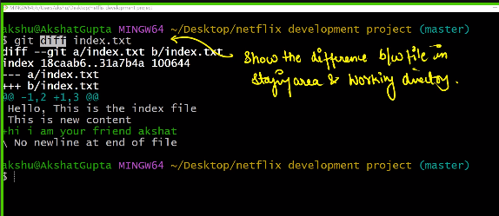

Git config

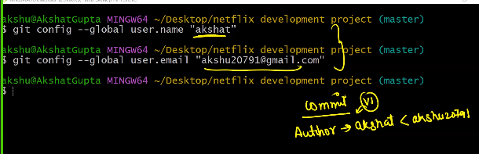

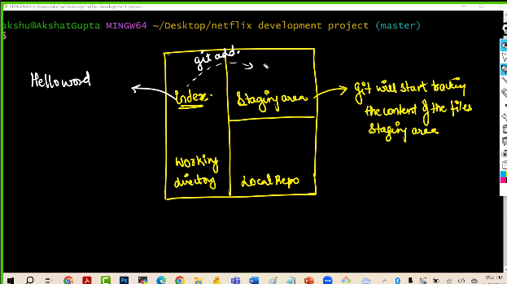 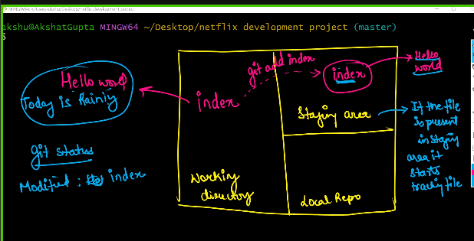 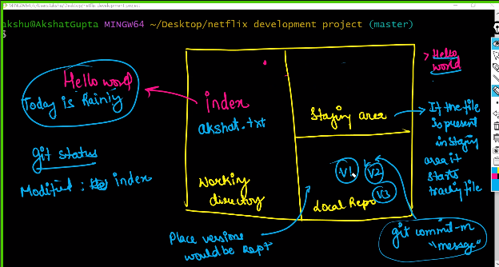

Linux course video link

<https://vimeo.com/700202539?share=copy>

<https://www.linkedin.com/in/akshat-g-57342938/>

Notes Drive link

<https://drive.google.com/drive/folders/1fUgjmpN1YbmYVBCswcngpqyW9ZmDh6Sc?usp=sharing>

git history 🡪 to see the

git log 🡪 to see the commits.

Git log – one line 🡪 to see the logs in single line

Touch file1 🡪

Repositories are 2 types 🡪 Public, Private both are secured.

Public🡪 Open-source software

Private 🡪 While Working for the client.

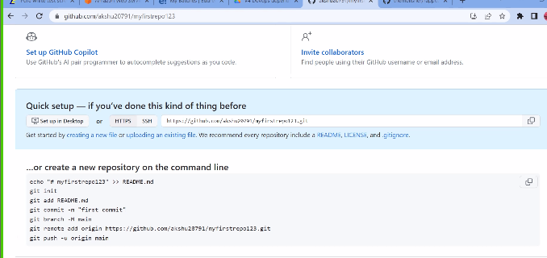

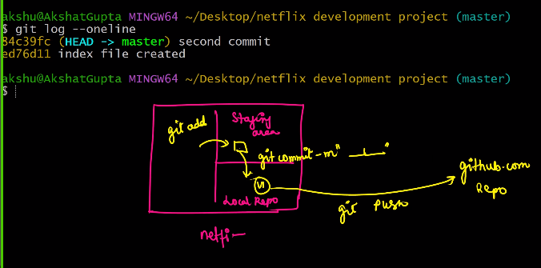

Git remote-v 🡪 to set a Origin where the codes to save

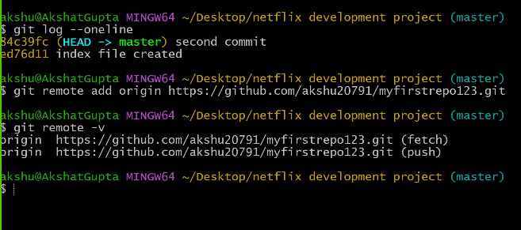

Git remote remove origin 🡪 to remove origin

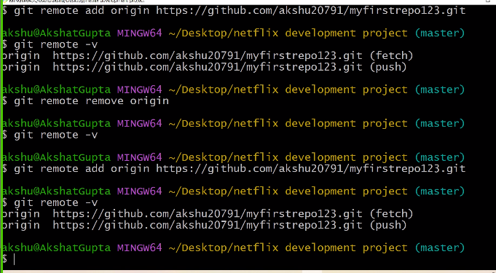

Git push-u origin master

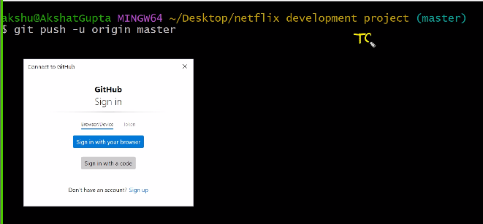

To get token

Top right in git hub account 🡪 settings🡪 developer options 🡪 Personal access token🡪 in notes put the name of the token & expiration days

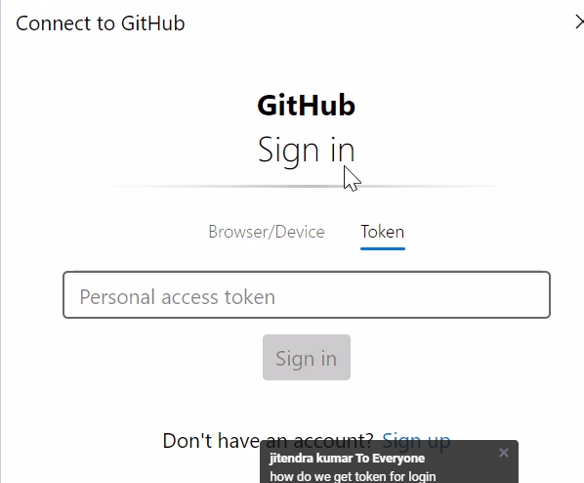

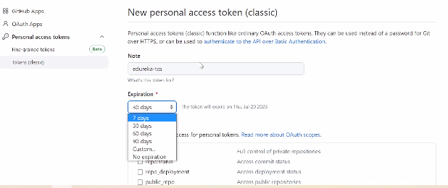

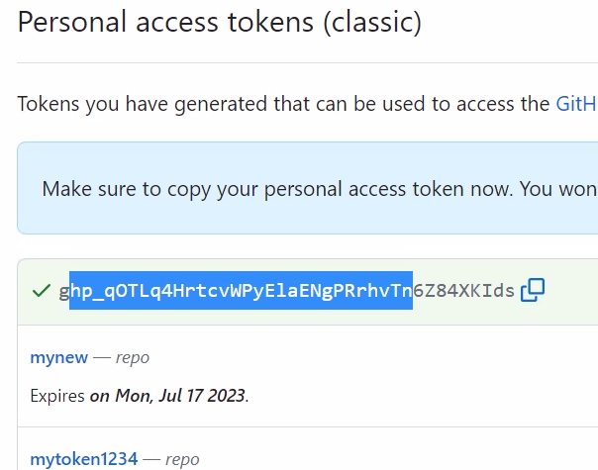

Cope the token paste in token box

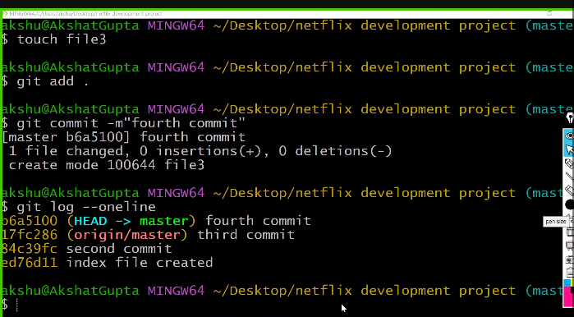

Git branch 🡪 it shows the list of the branch

Git branch branch1 🡪 create the branch 1 and entered into branch1

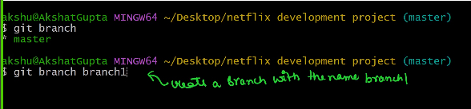

Git checkout branch1 🡪 check out from branch1.

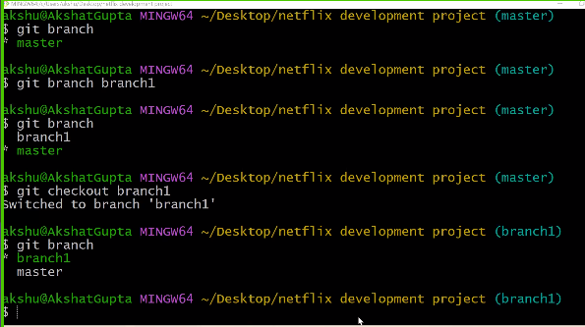

Branching is two types.

1. Merge 🡪 git merge
2. Rebase 🡪 git rebase.

C1, C2, C3, C4…… are commits

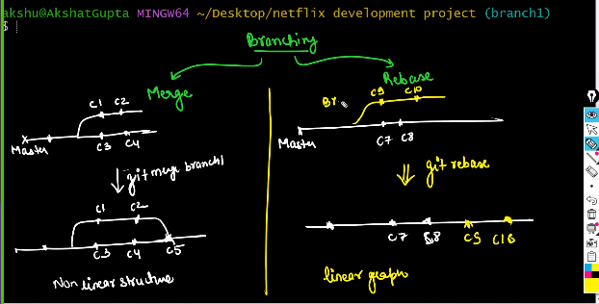

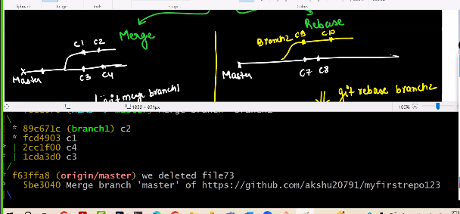

Books -- Git clone <https://github.com/akshu20791/Books>

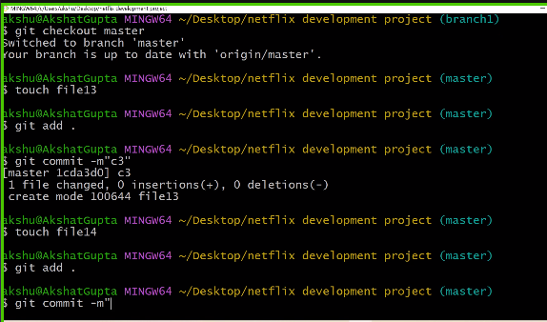

Git rebase

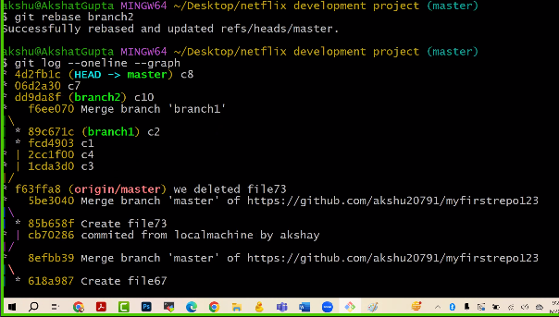

Installing the Git in AWS

Commend: yum git install -y

cd /🡪 Creating directory

mkdir 🡪

**JENKINS**

Jenkins is an automation tool, we can automate whole CI/CD pipeline

It’s open-source tool.

How to create AWS free account video link

<https://www.youtube.com/watch?v=P7hVdusJF7I>

<https://docs.google.com/document/d/1V2xub11uWYc5z4BGk7SaI_d-VLnKnUco/edit?usp=sharing&ouid=103157204066713600014&rtpof=true&sd=true>

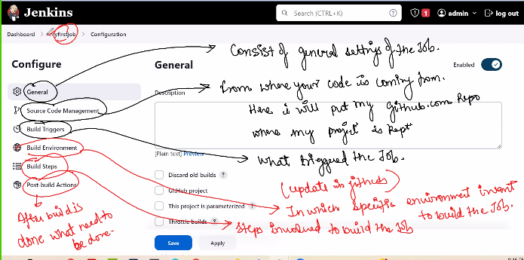

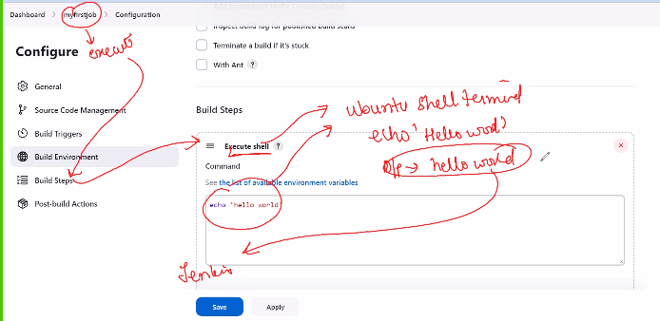

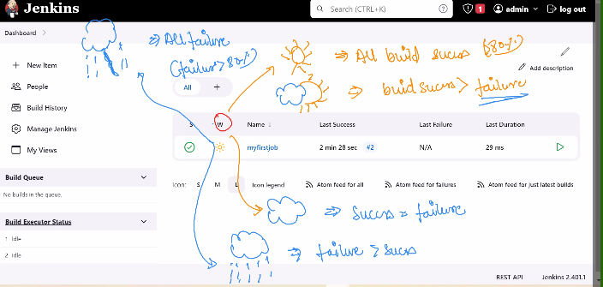

Git hub repo link : <https://github.com/akshu20791/DevOpsClassCodes>

Maven link <https://maven.apache.org/guides/introduction/introduction-to-the-lifecycle.html>

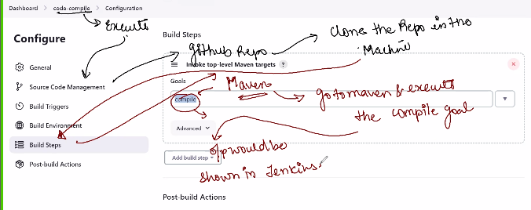

SCP🡪 Source code polling

Cronjob (Cronitor) link 🡪 [https://crontab.guru/#*_*_*_*](https://crontab.guru/#*_*_*_*)

Groovy script

Sh means execute commend it is linux comment

Access management 🡪 Admin

**ANSIBLE**

Ansible is configuration management tool.

Docs Steps to install software in server.

<https://docs.google.com/document/d/1mWZ3kJNfOhgqOtaCk4YPP0X68dFQwAck/edit?usp=sharing&ouid=103157204066713600014&rtpof=true&sd=true>

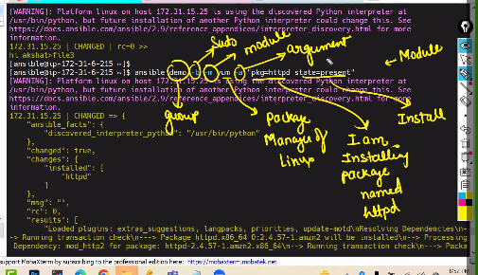

Asible

For change the password rekey

Docker

Docker is containerization service.

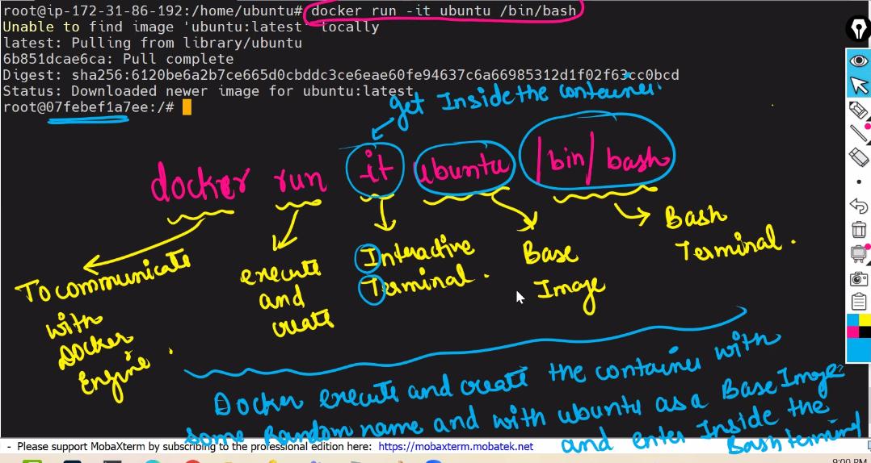

Access the docker

Container dose not have IP, so we can access via PORT num

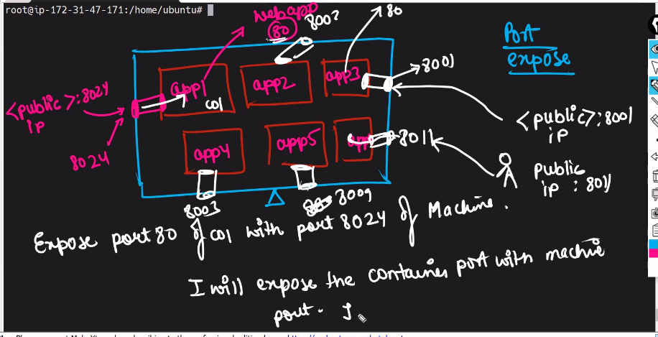

Docker attach is commend to enter the docker

Apt install git-y to install git in container

**Steps to create container**

1. Docker run -t –name ABC -p 8091 ubbuntu /bin/bash
2. Apt update
3. Apt install apache2
4. Service apache2 start
5. Cd/var/www/html 🡪 creating the file
6. Docker ps -a (ps means process) 🡪 It shows all the status of container
7. Docker commit c01 Subbaram img (execute the container with name of c01 and create the custom image of this container)
8. Docker images 🡪 it shows all the images which is presented in docker

Docker Volume

It is persistent volume

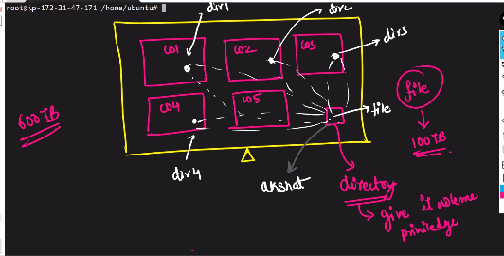

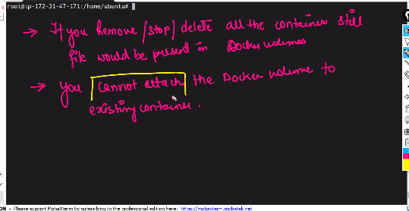

Create a directory

Docker volume create new_vol

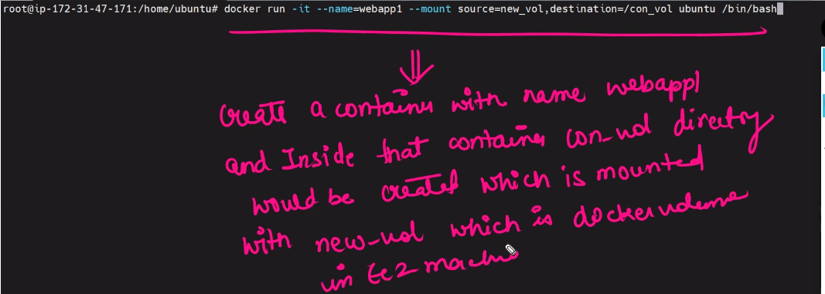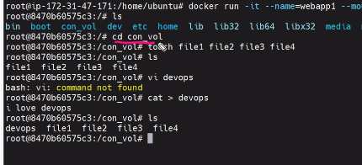

Docker volume inspect new_vol

Insect 🡪 give all the detailes

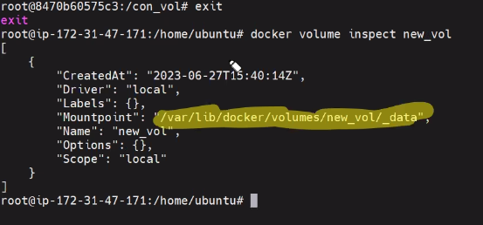

Docker commit <Container name ex C02> customing

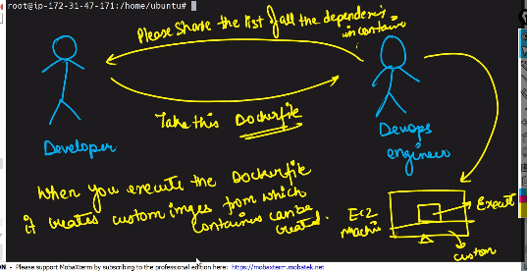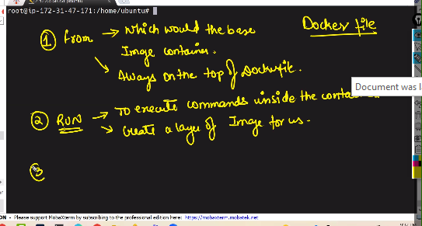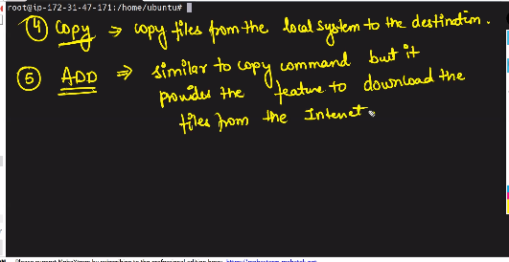

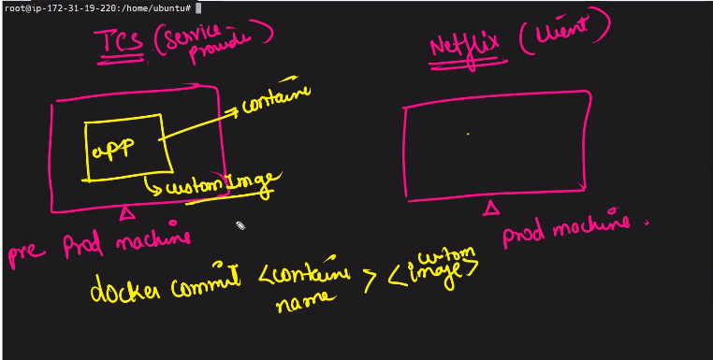 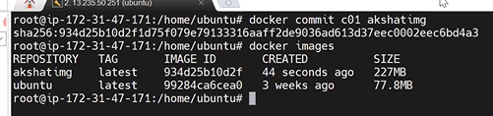

**Kubernetes K8s**

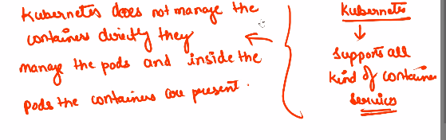

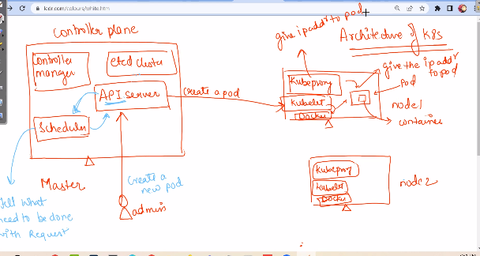

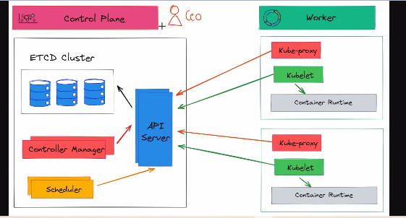

**Terraform**

Commends used in terraform

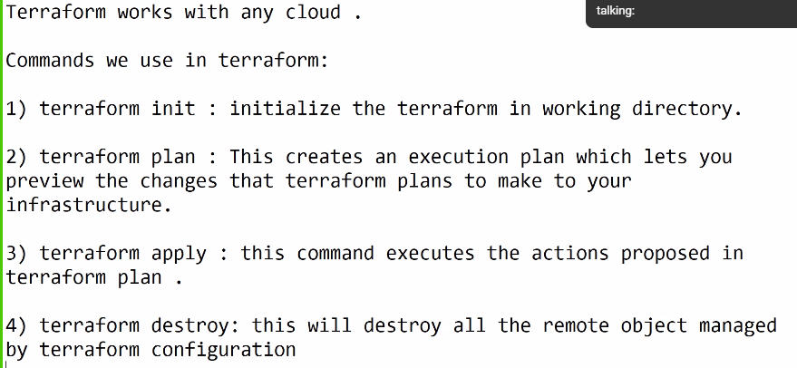

<https://developer.hashicorp.com/terraform/downloads>

<https://code.visualstudio.com/>

<https://registry.terraform.io/providers/hashicorp/aws/latest/docs>

